# Seven Chakra Album Cover AngelMeditations on the Angels The Seven Chakra - *Richard Irwin*

## Introduction

The inspiration behind the composition of these seven mediations was to help heal a young woman who had had a traumatic life as a teenager and who suffered from acute anxiety and OCD when I got to know her in her early twenties. The idea of Angels comes both from the idea of angelic voices, which are used in the music, and because the woman they were written for had a particular affinity with the idea of angels as having the power to help and protect her. She no longer suffers from anxiety and OCD. She is now is a loving relationship. When I asked her what she felt about the music she responded:

*I feel this divine music contains deeply healing tones & soothing vibrations for my soul... It is filled with angelic & cosmic frequencies to help align to my higher self. Helps open my sacred heart & enter more easily into meditative states so I may explore the beauty of the universe with ease & grace.*

There is scientific research being undertaken into the physiological and psychological effects of music (for example, the work being done by Nicola Miller, the Co-ordinator for the SMN Grampian Local Group). However, it was inspiration and intuition, rather than a scientific approach that lead to the composition of these pieces. I had become familiar with “meditation music” which sought, at one end of the scale, to provide either ambient sound, or, at the other, to actively affect the brain with binaural auditory beats in the EEG beta and EEG theta/delta frequency ranges. These are claimed to effect mood and performance. The Monroe Institute[1] use binaural beats to induce Out of the Body and Lucid Dream experiences.

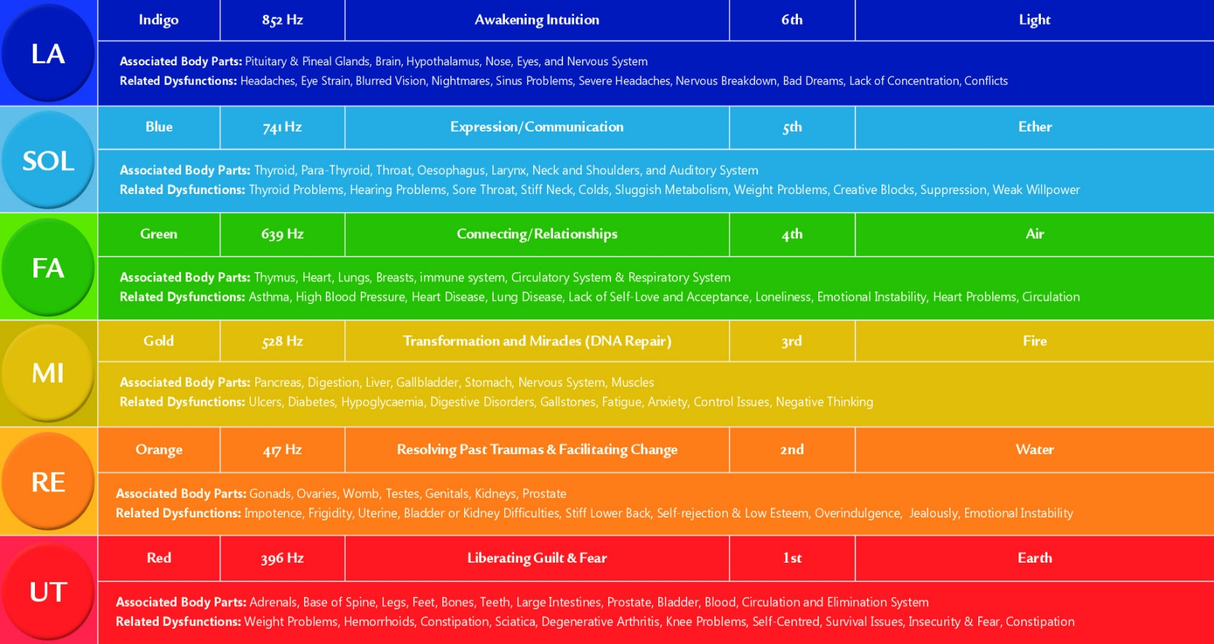

Figure 1- Solfeggio Scales - (source <http://www.esotericonline.net>)

I had also become familiar with the concept of the “lost” Solfeggio scale system (Figure 1) which is often used in meditation videos, promising positive effects. This lost system most likely matches the six of the ancient modes defined by the Greek Philosopher and student of Aristotle, Aristoxenus of Tarentum in his Elements of Harmony dating from the 4th Century BCE. They are used in Gregorian chant, so to say they are lost, as some claim, is probably incorrect.

It is believed these Greek defined modes were used in ancient music long before the 4th century, but whilst still used in some folk music, generally, modal music had fallen out of fashion in Europe by the 18th and 19th centuries when our more familiar Major and Minor scales came to dominate.

The reason there are only six as opposed to seven modal scales in the Solfeggio system is that the seventh, the Locrian mode christened *diabolus in musica* or *the devil in music* was banned by the Roman church. The strange haunting opening of Debussy’s *Prélude à l'après-midi d'un faune* uses the Locrian mode and provides a good example of its use.

I use all seven modes for the Chakra meditations and the Locrian mode is used for the 7th, the Crown Chakra, as, like our own spiritual development it does not resolve. It is interesting to note that the colours used in Figure 1 for the Solfeggio modes match those traditionally used to describe the first six Chakra.

The seven modes each start on a different note of the C major scale – C through to B. In normal major or minor scales each new scale would have a key signature, e.g. D - 2 Sharps, E – 4 Sharps, G – 1 Sharp, F – 1 Flat, etc. However in modal music there are no key signatures and throughout the seven movements no sharps or flats are used at all. This was quite a challenge to me as a composer, but each mode creates its own distinct character.

The Seven Chakra were not my first attempt at writing meditation music and one earlier piece in particular was reported to have a very positive effect on the mood of teenage children with autism, therefore I had some precedence for what I was attempting.

My intention in writing the Seven Chakra was to provide an aural experience that could positively rebalance the mind. All of the seven Chakras are important and interconnected and so, the theory goes, balancing one Chakra will create changes in other Chakras.

What I wanted to do during the listening or meditation process was stop the mind chatter and engage the emotions directly. The music is best experienced with quality headphones whilst lying down or sitting with a straight back. Both myself and others have experienced vibrational effects related to the relevant Chakra when listening.

Most mediation techniques use breathing, or a mantra, to focus the mind when it wanders. Here, simply refocus on the music. There are multiple strands and each strand can take you on a different journey.

A word of warning about the second meditation. From feedback received, this movement appears to be more controversial than most, focussing on the Sacral Chakra, which is the passion and pleasure centre and associated with sex. My original recording was much faster and almost Bacchanalian in tempo and temperament, however I was persuaded to slow it down. Rebalancing this Chakra was really important for the young woman for whom it was written and she responded to it well. However, older people, it appears, do have more difficulty with the movement.

The music is recorded using professional sound samples of real instruments and produced in the same way as many film scores are these days. I regret I could not afford a live orchestra and singers, whom, I think, would have made a better recording than my computer!

# The Chakra

The word Chakra is derived from Sanskrit and means ‘wheel’, or in Hindi traditions ‘Wheel of spinning Energy’. A Chakra is like a whirling, vortex like, powerhouse of energy. Within our bodies you have seven of these major energy centres and many more minor ones.

The theory is that Chakras connect your spiritual body to your physical one and regulate the flow of energy throughout. The seven mediations aim to recharge and rebalance the Chakras in order to have a positive effect on the listener. Each movement is separated by the chime on a Tibetan bell and the focus of your attention should move from one Chakra to the next, starting with the root and ending at the crown.

## Muladhara, Root Chakra - Ionian Mode (5:09)

The Root Chakra located at the base of the spine. It is the root of your being and establishes the deepest connections with your physical body, your environment and with the Earth. Muladhara is the most instinctual of all Chakras, it is of a primal, animal nature; your survival centre that initiates fight and flight responses.

Balancing the Root Chakra is important as we cannot grow and change unless we feel safe and secure.

## Swadhisthana, Sacral Chakra - Dorian Mode (2.53)

The Sacral Chakra is your passion and pleasure centre and it is located in the pelvic area. While the Root Chakra focusses on survival, the 2nd chakra seeks pleasure and enjoyment, it is the centre of feeling, emotion, pleasure, sensuality, intimacy, and creativity. It is also where fertility originates. After all, conceiving a child is a creative process.

There are many cultural struggles over sexual issues of our society. On one hand sexuality is magnified and glorified, and on the other hand it is rejected. This often results in either blocked or excessive Sacral Chakra issues.

Balancing the Swadhisthana Chakra is important to become passionate, sensual, creative, and connected.

## Manipura, Solar Plexus Chakra - Phrygian Mode (6.07)

The Solar Plexus Chakra, located between the navel and solar plexus, is the core of our personality, our identity, of our ego and the centre of willpower. While the Sacral chakra seeks pleasure and enjoyment, the third chakra is all about the perception of who you are and is the centre of self-esteem.

Balancing the Manipura helps your self-esteem, will-power, self-discipline, and warmth in your personality. It builds your confidence, responsibility and reliability.

## Anahata, Heart Chakra - Lydian Mode (5.49)

The Heart Chakra, located in the centre of your chest is the wellspring of love, warmth, compassion, and joy. Anahata moves your life through love. It is the centre of your deep bonds with others, your sense of caring and compassion, your feelings of self-love, altruism, generosity, kindness, and respect.

As the central Chakra, Anahata is integrating and unifying, bringing about wholeness and hence it is your healing centre. Indeed, most spiritual traditions recognize love as the ultimate healing force; the energy that is the most fundamental part of the universe, and of ourselves.

When balanced Anahata energy flows freely, you are loving to others, and also loving of yourself.

Visuddha, Throat Chakra - Mixolydian Mode (5.28)

The Throat Chakra is the first of the higher or spiritual chakras and is located in the region of neck and shoulders. The Chakra supports acceptance of your originality, expressing your authentic voice and speaking your truth.

Balancing the Visuddha allows you to seek the knowledge of truth, to move beyond physical limitations and beyond cultural and family conditioning. It is linked to personal integrity and a sense of honour. It allows you to express who you are and what you stand for, but also allows to be a good listener and to be empathetic to others.

# Ajna, Third Eye Chakra - Aeolian Mode (10.51)

The Third Eye Chakra allows us to access our inner guidance that comes from the depths of our being. It is the seat of wisdom and allows us to cut through illusion and to access deeper truths - to see beyond the mind, beyond the words. It is located in the brain, at the brow, above the eyes.

Balancing the Ajna allows us to experience clear thought and spiritual contemplation in order to access our inner guidance that comes from the depths of our being. It allows us to cut through illusion and to access deeper truths - to see beyond the mind, beyond the words.

The "way of the third eye" is seeing everything as it is from a point of "witness" or "observer", or from simply being mindful - moment by moment. It means examining self-limiting ideas and developing wisdom that comes from a perspective that transcends the duality of good or bad, black or white. It means seeing and helping others to see the deeper meanings of the situations in their lives.

The Ajna is holistic in nature, so when balanced, both hemispheres of the brain function in a synchronistic fashion. The right hemisphere's creativity and synthetic thinking is integrated and balanced with left’s logical and analytical thinking.

## Sahasrara, Crown Chakra - Locrian Mode (7:30)

The Crown Chakra is the highest Chakra associated with the physical body and connects us with the universal source of creation. It is located at the crown of the head. It is the meeting point between finite (the body and the ego) and infinite (the universe and soul).

Balancing Sahasrara allows us to experience mystical oneness with everyone and everything in nature without the need for intellectual knowing. It helps us achieve serenity, joy, and peace. It is the way of transcending the ego and knowing that all of creation is interconnected at a fundamental level, a level that some call the "Akasha" or "Zero Point Field".

According to Tantric philosophy, the seventh chakra is both a receiver and giver of energy and consciousness. It receives energy to sustain life and it gives back the personal energy to unite with the collective pool of consciousness.

1. <https://www.monroeinstitute.org>